

# Year 10 Investigation 3

## Name: ____SOLUTIONS______________________________________

Consecutive Numbers

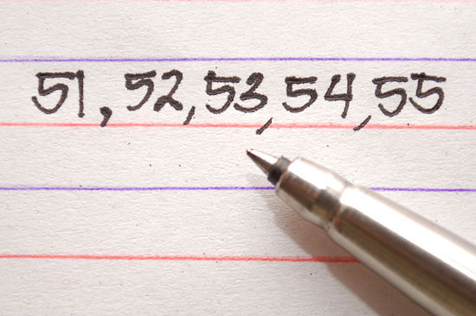

|  |  |
| --- | --- |
| Total (47) |  |
| % |  |
| Progress |  |

1. 6 can be written as the **sum** of 3 **consecutive** whole numbers (6=1+2+3).

(Consecutive numbers follow one after another. They are next to each other in order.) Show all the possible ways you can write the numbers 2 to 16 as sums of consecutive whole numbers? Note: This will not be possible for all numbers. (14 marks)

2: Not possible

3: 1+2

Not necessary to have all possible combinations

1 mark per number for at least 1 correct way

4: Not possible

5: 2 + 3

6: 1+2+3

7:3 + 4

8: Not possible

9: 4+5, 2+3+4

10: 1 + 2 + 3 + 4

11: 5 + 6

12: 3 + 4 + 5

13: 6 + 7

14: 2 + 3 + 4 + 5

15: 7 + 8, 4 + 5 + 6, 1 + 2 + 3 + 4 + 5

16: Not possible

1. Which of these numbers could not be written as the sum of consecutive whole numbers? (2 marks)

2, 4, 8, 16 (1 mark)

What sequence do these numbers represent?

2n

or doubling previous term (1 mark)

1. Pick any 6 **pairs** of consecutive whole numbers and make a list of their sums: (5 marks)

Numbers Sum

1. 1, 2 3

Examples only

1/2mark per ANY correct response

2. 2, 3 5

3. 3, 4 7

4. 4, 5 9

5. 5, 6 11

6. 6,7 13

1. What do the sums have in common? (1 mark)

All are odd

1. Using n and n+1 as your pair, prove your discovery in a) using algebra, given that 2n+1 must be an odd number. (1 mark)

n + (n + 1) = 2n + 1

2n must be even so when you add 1 it will always be odd

1. Pick any 6 sets of **3** consecutive whole numbers and make a list of their sums: (7 marks)

Numbers Sum

1. 1, 2, 3, 6

Examples only

1/2mark per ANY correct response

2. 2, 3, 4, 9

3. 3, 4, 5 12

4. 4, 5, 6 15

5. 5, 6, 7 18

6. 6, 7, 8 21

1. What do the sums have in common? (1 mark)

all are multiples of 3

1. What is the connection between the middle number and the sum?

sum = middle number x 3 (1 mark)

1. How could you calculate 107+108+109 without adding the numbers? (1 mark)

108 x 3

1. If your 3 numbers are n, n+1 and n+2 then prove your discovery in a) using algebra (1 mark)

n + (n+1) + (n +2) = 3n + 3

= 3(n + 1)

as n +1 is the middle number, the sum is always the middle number x 3

1. Pick any 6 sets of 4 consecutive numbers and list their sums and half their sums: (7 marks)

Numbers Sum Sum/2

1. 4 + 5 + 6 + 7 22 11

2. 1 + 2 + 3 + 4 10 5

Examples only

1 mark per ANY correct response

½ mark if not halved

3. 2 + 3 + 4 + 5 14 7

4. 3 + 4 + 5 + 6 18 9

5. 4 + 5 + 6 + 7 22 11

6. 5 + 6 + 7 + 8 26 13

1. If you write the numbers as (*n* −1) + *n* + (*n* +1) + (*n* + 2), then what can you say about the numbers that can be written as the sum of 4 consecutive whole numbers, from the result of combining then factorising this expression? (1 mark)

(n – 1) + n + (n + 1) + (n + 2) = 4n + 2

= 2(2n + 1)

So the sum of 4 consecutive numbers will always be even

1. What do you notice about the middle 2 numbers? (1 mark)

sum = double the sum of the middle 2 numbers

1. Pick any 6 sets of 5 consecutive whole numbers and list their sums: (7 marks)

Numbers Sum

1. 1, 2, 3, 4, 5, 15

Examples only

1/2mark per ANY correct response

2. 2, 3, 4, 5, 6, 20

3. 3, 4, 5, 6, 7 25

4. 4, 5, 6, 7, 8 30

5. 5, 6, 7, 8, 9 35

6. 6, 7, 8, 9, 10 40

1. What do the sums have in common? (1 mark)

all are multiples of 5

1. What is the connection between the middle number and the sum?

sum = 5 x middle number (1 mark)

1. How can you calculate 41+42+43+44+45 without adding the numbers? (1 mark)

43 x 5

1. If your 5 numbers are n, n+1, n+2, n+3 and n+4 then prove your discovery in a) using algebra (1 mark)

n + (n + 1) + (n + 2) + (n + 3) + (n + 4) = 5n + 10

= 5(n + 2)

As n + 2 is the middle number, the sum will always be 5 x the middle number

1. Starting with 3 + 4 ,

repeatedly add a consecutive *integer* to both ends. Repeat 5 times. (5 marks)

i.e. 3 + 4

2 + 3 + 4 + 5 (once)

1 mark per line

1 + 2 + 3 + 4 + 5 + 6

0 + 1 + 2 + 3 + 4 + 5 + 6 + 7

- 1 + 0 + 1 + 2 + 3 + 4 + 5 + 6 + 7 + 8

- 2 + - 1 + 0 + 1 + 2 + 3 + 4 + 5 + 6 + 7 + 8 + 9

Explain why the sums are always a multiple of 7. ( 1 mark)

We started with 7 and each time we add 7 to the total

eg 1 and 6, 0 and 7, -1 and 8

so the sum will always be a multiple of 7